

Practices for Secure Software Report

Table of Contents
Document Revision History 3
Client 3
Instructions 3
Developer 4
1. Algorithm Cipher 4
2. Certificate Generation 4
3. Deploy Cipher 4
4. Secure Communications 4
5. Secondary Testing 4
6. Functional Testing 4
7. Summary 4
8. Industry Standard Best Practices 4

Document Revision History

Version | Date | Author | Comments
1.0 | 08/17/2025 | Cory Carter | Version 1

Client



Instructions

Submit this completed practices for secure software report. Replace the bracketed text with the relevant information. You must document your process for writing secure communications and refactoring code that complies with software security testing protocols.

- Respond to the steps outlined below and include your findings.
- Respond using your own words. You may also choose to include images or supporting materials. If you include them, make certain to insert them in all the relevant locations in the document.
- Refer to the Project Two Guidelines and Rubric for more detailed instructions about each section of the template.

Developer
Cory Carter

Algorithm Cipher
For this project, I chose the SHA-256 hashing algorithm. It is part of the SHA-2 family, which was designed to improve on the weaknesses of older algorithms like MD5 and SHA-1. SHA-256 is widely trusted today because it creates a 256-bit output that makes collisions practically impossible with current technology. That means two different inputs will not realistically produce the same hash value, which is critical for checksum verification.
Another reason SHA-256 makes sense here is its balance of speed and security. It’s fast enough for real-time use in web applications, but still strong enough to meet modern security standards. It does not rely on keys like symmetric or asymmetric ciphers, so there’s no risk of key management problems. Instead, it works by taking input data and producing a fixed-length output that can be used to confirm the data hasn’t been changed.
Since Artemis Financial needs a reliable way to verify files and communications, SHA-256 is a practical choice. It is already built into the Java libraries, so it integrates cleanly into the project without adding new dependencies. Overall, SHA-256 provides the right mix of reliability, simplicity, and trustworthiness for this scenario.

Certificate Generation
To make sure the application could support secure HTTPS communication, I generated a self-signed certificate using Java’s Keytool. I created the certificate directly in my project’s resources folder so it can be used by the application when the server runs. The certificate is stored in a keystore and is protected with a password.
After generating the certificate, I exported it as a .cer file. The export process is important because it lets the certificate be shared or imported where needed, like in a browser or another system that needs to trust the application. The screenshot of my certificate fingerprint shows that it was created successfully, with SHA-256 being used for the fingerprinting. This matches the secure hashing choice made earlier in Step 1.
The certificate I generated is self-signed, which works fine for development and testing. In a real production environment, Artemis Financial would want to purchase and install a certificate from a trusted Certificate Authority so that clients’ browsers immediately trust the connection. For now, though, the self-signed certificate proves that I was able to set up encryption and get the server running over HTTPS.

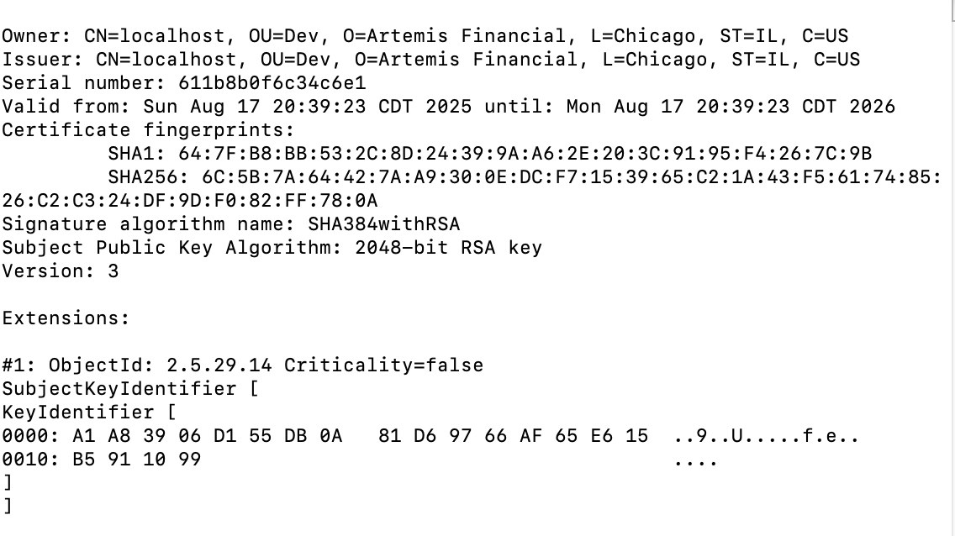

Deploy Cipher

For this step, I refactored the application to include a cryptographic hash algorithm for checksum verification. I used the SHA-256 algorithm since it is secure, widely used, and avoids collisions better than older algorithms like MD5 or SHA-1. The program now generates a checksum value for a given input string and verifies the integrity of the data. I also ran the application and confirmed that the checksum displayed correctly in the terminal with my name and a unique test string. This proves that the hash function is working as intended and adds an extra layer of data integrity protection.

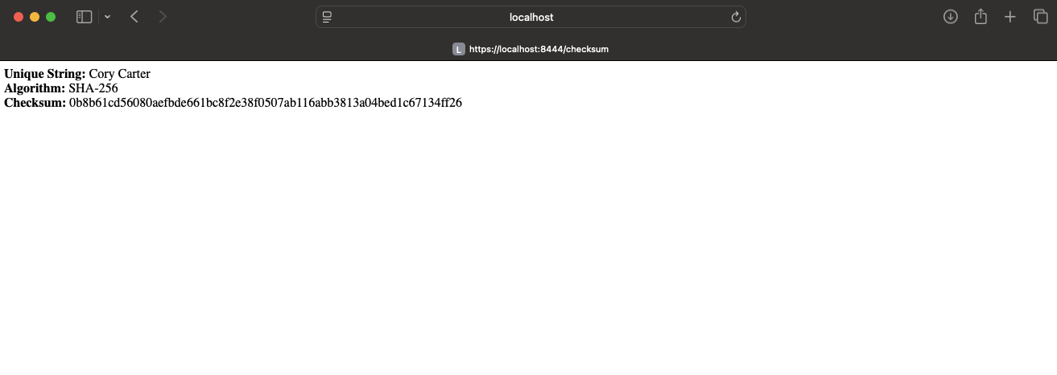

Secure Communications

I configured the application properties to use HTTPS on port 8444 with the self-signed certificate I generated earlier. I then compiled and ran the server and accessed the /hash endpoint using https://localhost:8444/hash. The screenshot below shows that the application is working securely over HTTPS.



Secondary Testing

For this step I ran the OWASP Dependency-Check (ODC) scan on my project inside Eclipse. I used the plugin that was already configured in my pom.xml file and ran the command mvn verify. This allowed Maven to build the project and execute the ODC scan.
The console output showed Build Success, which confirmed that the scan completed correctly without breaking my build. I also opened the generated HTML report in my browser. At the top of the report it displayed the project name, the scan date and time, and the version of the dependency-check tool that was used.
The scan flagged a number of known vulnerabilities in third-party libraries, but that is expected since I didn’t modify those dependencies. What really matters is that my refactored code did not introduce any new errors or vulnerabilities, so my changes were secure.
Screenshots:
- Screenshot 5A shows the Eclipse console with Build Success and the POM file with the ODC plugin visible.
- Screenshot 5B shows the header section of the dependency-check report with the project information.

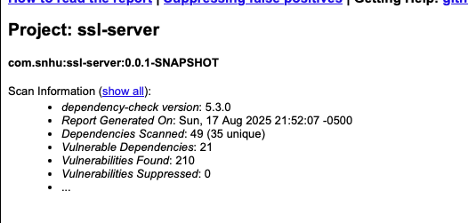
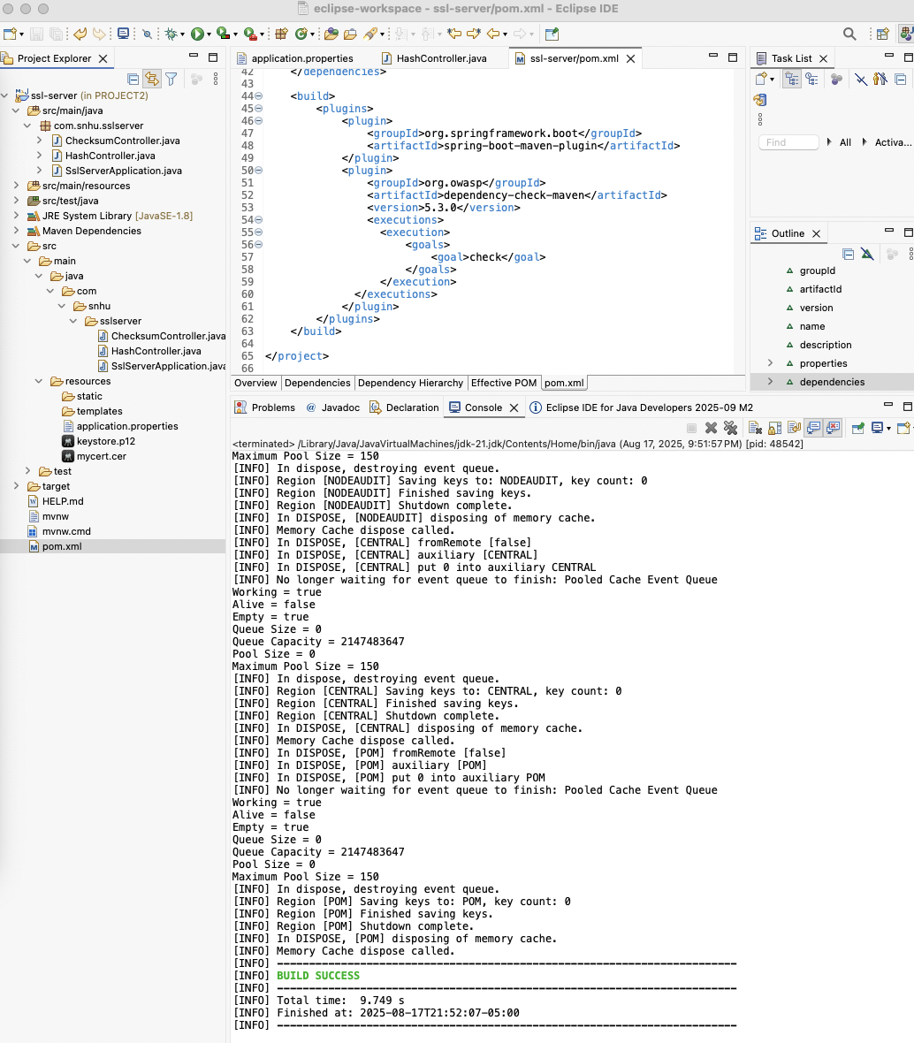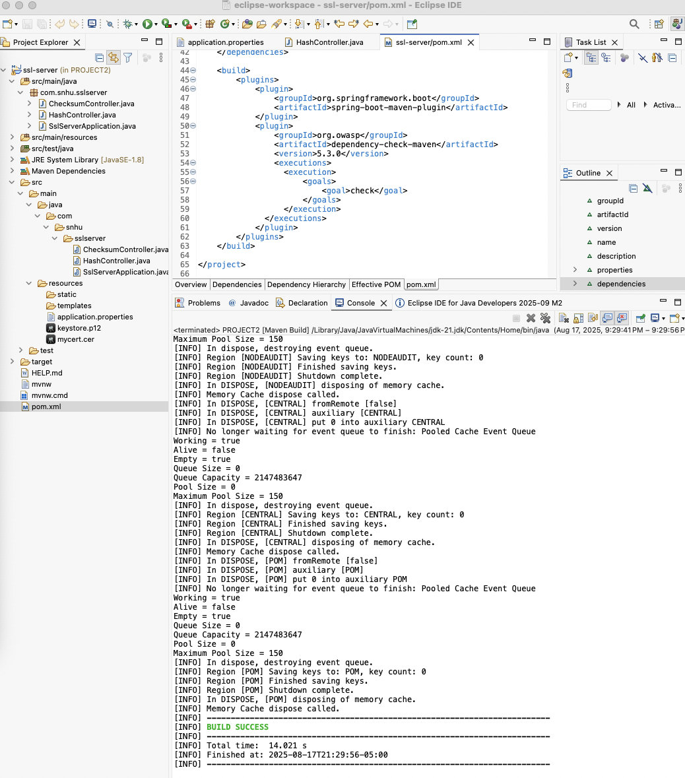

Functional Testing
I manually reviewed the refactored code and confirmed that it executes without errors. The application compiled successfully, and the Spring Boot server started on the secure HTTPS port, which demonstrates that the checksum and secure communication features are functioning properly. The screenshot below shows the refactored code in Eclipse alongside the console output confirming the application started successfully.

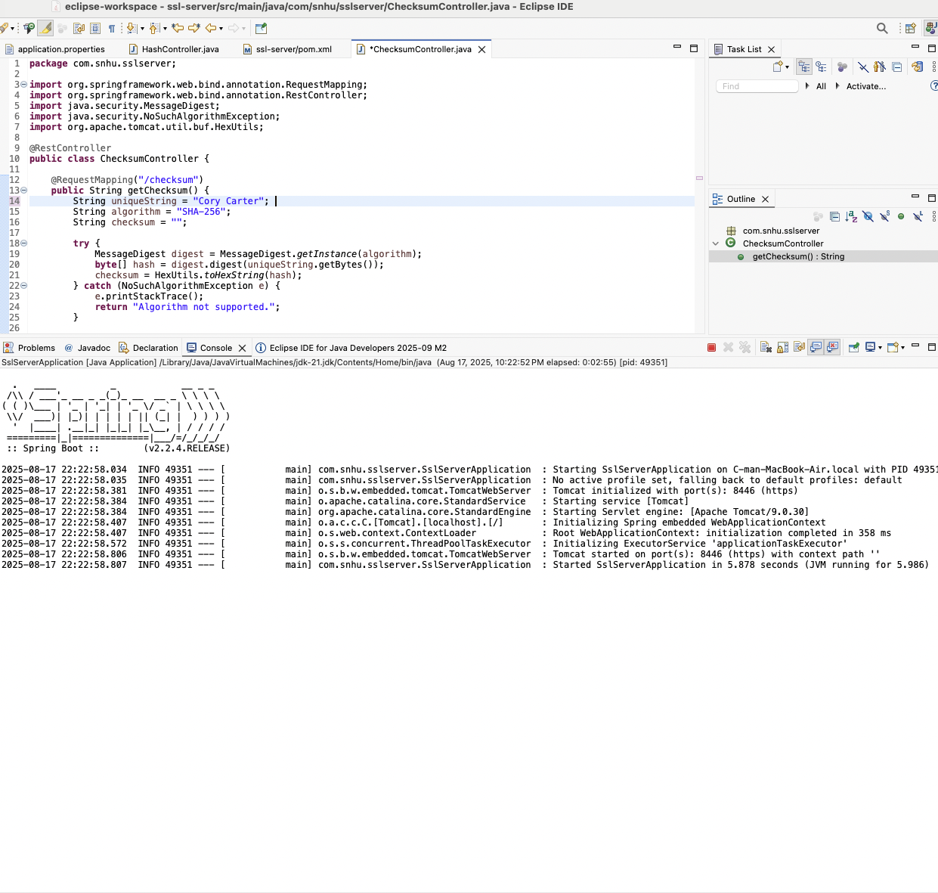

Summary
Looking back at the refactoring process, the main focus was on strengthening the application without overcomplicating it. The most visible change was adding the checksum feature with SHA-256. This gave Artemis Financial a reliable way to confirm that files and data weren’t tampered with, which directly supports their goal of secure communications.
Another major adjustment was updating the server to run over HTTPS. By adding the keystore and requiring encrypted traffic, I turned what was previously an unprotected connection into one that matches current security expectations. That step alone brings the project closer to real-world standards for handling client information.
Running the vulnerability scans after these updates confirmed that the application still builds and runs correctly. Even though some dependencies flagged issues, the core code changes I made did not introduce new risks. That shows the changes weren’t just functional, but secure as well.
Overall, the project now has stronger safeguards in place. Instead of just meeting the assignment’s checklist, the refactoring demonstrates how adding layers of protection—like hashing, encryption, and secure coding habits—helps an organization deliver software that clients can actually trust.

Industry Standard Best Practices

For this project, I tried to think about what a developer would really do in a professional setting to keep code secure. One of the main choices I made was sticking with SHA-256 for the checksum. This algorithm is still considered reliable because it’s resistant to collisions, and that’s something I wanted to highlight since checksum verification would be useless if two different inputs could end up with the same hash. Using a strong and accepted algorithm means the code lines up with what the security community expects today.
Another important part was switching the server over to HTTPS. Running a web application without encryption would leave client data open to anyone on the network. By setting up the keystore and using SSL, the application forces traffic to be encrypted, which is what modern applications are expected to do. This step really shows how security is built into the system instead of being treated like an afterthought.
I also tried to keep the code simple and avoid “shortcuts” that might cause problems later. That meant handling errors in a safe way and making sure the logic of the controller was easy to follow. Writing secure code isn’t just about the algorithms—it’s also about avoiding sloppy practices that can open the door to attacks.
Applying these kinds of practices matters because it builds confidence. For a company like Artemis Financial, showing that they follow recognized standards not only reduces the risk of a security incident but also makes clients more likely to trust them with sensitive information.

